J2ME Sample Game 16 – Audio MIDlet

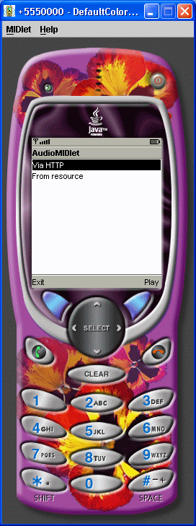

/*
Wireless Java 2nd edition
Jonathan Knudsen
Publisher: Apress
ISBN: 1590590775
*/
import java.io.*;
import javax.microedition.io.*;
import javax.microedition.lcdui.*;
import javax.microedition.midlet.*;
import javax.microedition.media.*;
public class AudioMIDlet
extends MIDlet
implements CommandListener, Runnable {
private Display mDisplay;
private List mMainScreen;
public void startApp() {
mDisplay = Display.getDisplay(this);
if (mMainScreen == null) {
mMainScreen = new List("AudioMIDlet", List.IMPLICIT);
mMainScreen.append("Via HTTP", null);
mMainScreen.append("From resource", null);
mMainScreen.addCommand(new Command("Exit", Command.EXIT, 0));
mMainScreen.addCommand(new Command("Play", Command.SCREEN, 0));
mMainScreen.setCommandListener(this);
}
mDisplay.setCurrent(mMainScreen);
}
public void pauseApp() {}
public void destroyApp(boolean unconditional) {}
public void commandAction(Command c, Displayable s) {
if (c.getCommandType() == Command.EXIT) notifyDestroyed();
else {
Form waitForm = new Form("Loading...");
mDisplay.setCurrent(waitForm);
Thread t = new Thread(this);
t.start();
}
}
public void run() {
String selection = mMainScreen.getString(
mMainScreen.getSelectedIndex());
boolean viaHttp = selection.equals("Via HTTP");
if (viaHttp)
playViaHttp();
else
playFromResource();
}
private void playViaHttp() {
try {
String url = getAppProperty("AudioMIDlet-URL");
Player player = Manager.createPlayer(url);
player.start();
}
catch (Exception e) {
showException(e);
return;
}
mDisplay.setCurrent(mMainScreen);
}
private void playFromResource() {
try {
InputStream in = getClass().getResourceAsStream("/relax.wav");
Player player = Manager.createPlayer(in, "audio/x-wav");
player.start();
}
catch (Exception e) {
showException(e);
return;
}
mDisplay.setCurrent(mMainScreen);
}
private void showException(Exception e) {
Alert a = new Alert("Exception", e.toString(), null, null);
a.setTimeout(Alert.FOREVER);
mDisplay.setCurrent(a, mMainScreen);
}
}

